451
Introduction
Nitrogen-fixing leguminous trees (NFLTs) are being planted on a wide scale in the tropics to provide fuel wood, construction materials, fodder, and nitrogen-rich biomass for improving soil fertility. In most cases, exotic species are being planted, as they have been shown to outperform indigenous taxa in terms of vigor (Hughes and Styles 1987). Although biological nitrogen fixation is an important attribute of NFLTs, little has been done to delineate their rhizobial specificity in terms of nodulation and nitrogen fixing effectiveness. Such knowledge is required to develop effective inoculants for NFLTs, since they are introduced into soils where they have not previously been cultivated and which may lack compatible rhizobia.
According to Allen and Allen (1981), the first description of rhizobia from a leguminous tree was recorded in 1887 on isolates from Robinia pseudoacacia. Several tree species
¹Journal series No. 3638 of the Hawaii Institute of Tropical Agriculture and Human Resources.
²Present address: Department of Forestry, Box 8002, North Carolina State University, Raleigh, NC 27695, U.S.A.
³Author to whom all correspondence should be addressed.
Printed in Canada / Imprim€ au Canada
were subsequently investigated for nodulation (see Fred et al. 1932). However, legume cross-inoculation groups as initially developed included few perennial shrubs or trees. A landmark contribution in this area was that of Allen and Allen (1936). In a survey of the leguminous flora of Hawaii they recorded nodulation of plants ranging in age from 1 to 20 years and recovered isolates from the nodules. Reciprocal cross-inoculation tests were performed with these isolates and Vigna unguiculata. Based on these tests, they identified 72 trees and shrubs that were new additions to the cowpea cross-inoculation group. Further cultural and symbiotic characterization of 54 strains from 28 of these species showed that in general they were typical of "cowpea" bacteria (Bradyrhizobium sp. in current usage) in their slow growth and alkaline media reactions (Allen and Allen 1939). The strains exhibited marked variation in infectiveness and effectiveness of nodulation on 20 host members of the cowpea cross-inoculation group (Allen and Allen 1939).
The work of Trinick (1965, 1968, 1980) established that true fast-growing rhizobia also nodulate tree legumes. His work in Papua New Guinea showed that Leucaena leucocephala did not nodulate with slow-growing rhizobia from 41 tropical legumes, and that the homologous isolates
Rhizobia that nodulate tree legumes: specificity of the host for nodulation
and effectiveness¹

DAN TURK ² AND HAROLD H. KEYSER ³
University of Hawaii, NifTAL Project, 1000 Holomua Road, Paia, HI 96779-9744, U.S.A.
Received August 26, 1991
Revision received December 18, 1991
Accepted January 2, 1992

TURK, D., and KEYSER, H. H. 1992. Rhizobia that nodulate tree legumes: specificity of the host for nodulation and effectiveness. Can. J. Microbiol. 38: 451-460.
Rhizobial specificity, defined in terms of nodulation and nitrogen-fixing effectiveness characteristics of a group of rhizobia on a host legume, serves as a basis for predicting the need to inoculate, selecting species for most probable number plant-infection assays, and preparing rhizobial inoculants suitable for a range of legume species. A series of inoculation experiments were performed under growth room and greenhouse conditions to delineate rhizobial specificity of a variety of tree legumes. Gliricidia sepium, Calliandra calothyrsus, and Leucaena leucocephala nodulated effectively with rhizobia isolated from each of the three genera. With a few exceptions, Sesbania grandif7ora and Robinia pseudoacacia nodulated effectively only with rhizobial strains isolated from each genus respectively. A range of specificity was found among species that nodulate with Bradyrhizobium. Whereas Acacia mearnsii nodulated with most strains but fixed N₂ effectively with relatively few, Acacia mangium and Lysiloma latisiliqua were specific for both nodulation and effectiveness.
Key words: nitrogen fixation, effectiveness, nodulation, rhizobia, tree legumes.

TURK, D., et KEYSER, H. H. 1992. Rhizobia that nodulate tree legumes: specificity of the host for nodulation and effectiveness. Can. J. Microbiol. 38 : 451-460.
Definie en termes de nodulation et d'efficacite de fixation de 1'azote, la specificite rhizobienne qui caracterise un
groupe de rhizobiums de legumineuses-hotes a servi de base pour les aspects suivants : predire la necessite d'inoculer, selectionner des especes pour des essais du nombre le plus probable de plantes inoculees et preparer des inoculants rhizobiens qui conviennent a une gamme d'especes de la famille des legumineuses. Une serie d'experiences d'inoculation ont ete poursuivies en chambre de croissance et dans des conditions de champ pour determiner la specificite rhizobienne dune vari6te d'arbres de cette famille. Les Gliricidia sepium, Calliandra calaothyrsus et Leucaena leucocephala ont effectivement produit des nodosites avec des souches rhizobiennes isol6es de chacun des trois genres. A peu d'exceptions pres, les Sesbania grandiflora et Robinia pseudoacacia ont forme des nodosites avec les souches rhizobiennes isolees de chacun des genres respectifs. Une variation etendue de specificite a ete decelee parmi les especes qui ont forme des nodosites avec le Bradyrhizobium. D'autre part, tandis que 1'Acacia mearnsii a forme des nodosites avec
la plupart des souches alors que peu d'entre elles ont ete efficace pour la fixation de N₂, 1'Acacia mangium et le Lysiloma latisiliqua ont ete specifiques a la fois pour la nodulation et pour 1'efficacite.
Mots cles : fixation de 1'azote, efficacite, nodulation, rhizobiums, arbres de la famille des legumineuses.
[Traduit par la redaction]
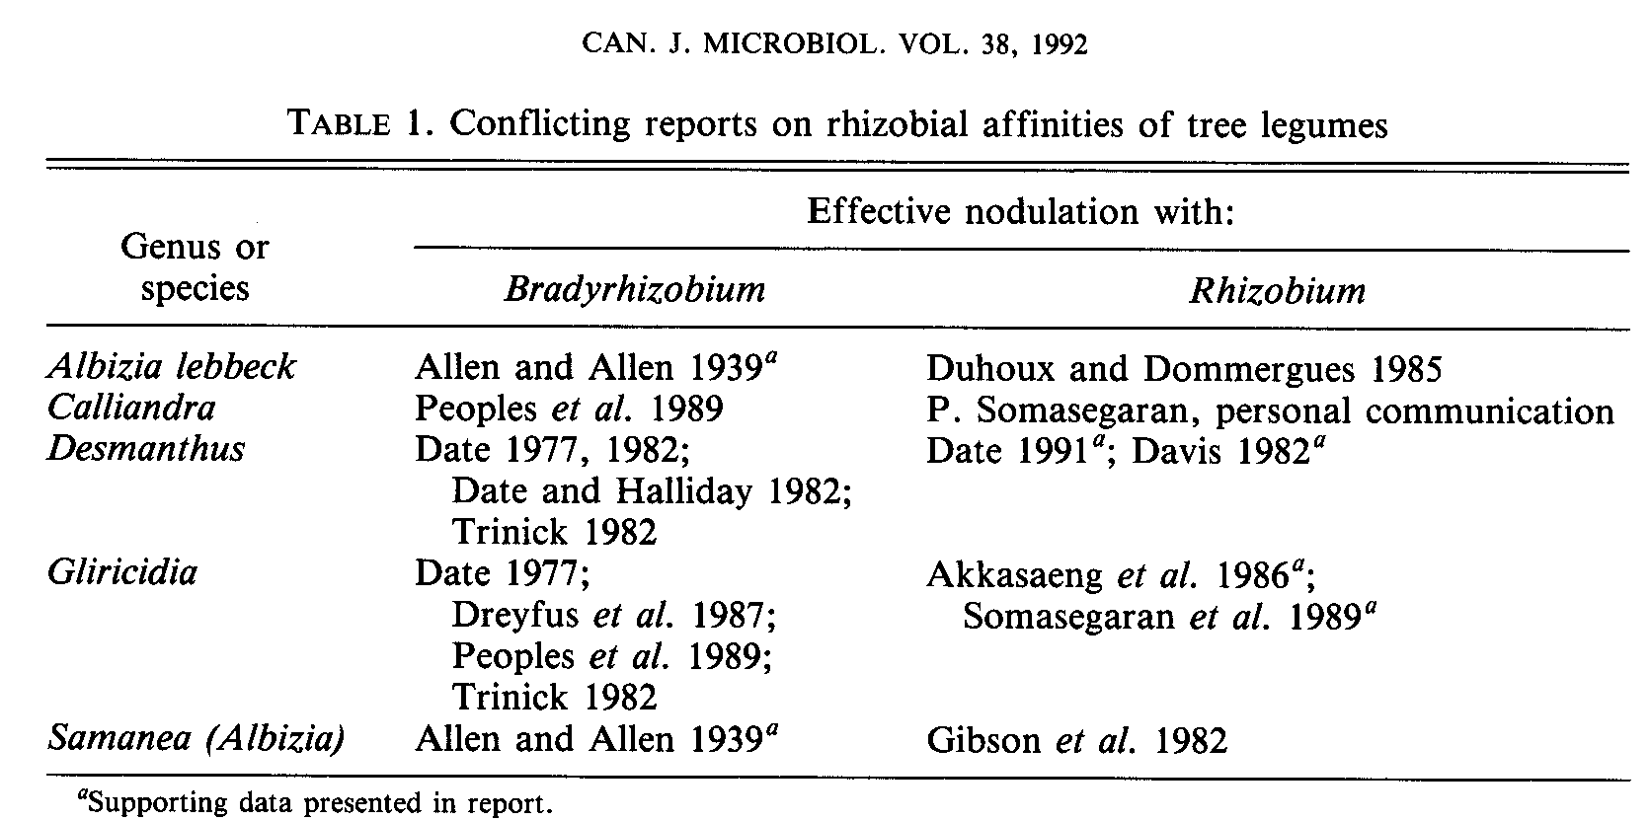
452
were fast growers, which utilized a wide array of sugars (characteristic of Rhizobium) and had some serological relatedness with Rhizobium meliloti (Trinick 1965). Subsequent work found that rhizobia isolated from Mimosa pudica, Mimosa invisa, Acacia farnesiana, and Sesbania grandif7ora were also fast growers, with some strains related to the fast-growing Rhizobium meliloti (Trinick 1968, 1980).
Dreyfus and Dommergues (1981) found differential affinity among species of Acacia for symbiotic effectiveness with Rhizobium and Bradyrhizobium, with Acacia seyal and Acacia sieberana nodulating effectively with rhizobia from both genera. Effective nodulation with rhizobia from both genera has since been reported for Acacia longifolia (Barnet et al. 1985) and Prosopis glandulosa (Jenkins et al. 1987).
Despite these exceptions, tree legumes in general nodulate effectively almost exclusively with either Rhizobium or Bradyrhizobium (Dreyfus et al. 1987). Tree species that nodulate effectively with fast-growing rhizobia are recognized as being specific for nodulation and effectiveness (Duhoux and Dommergues 1985; Gibson et al. 1982; Trinick 1982), whereas species that nodulate with Bradyrhizobium are less specific (more promiscuous) for both characteristics (Graham and Hubbell 1975; Date 1977, 1982).
There is considerable confusion surrounding the rhizobial affinities of many tree species (Table 1). Apparent misidentification of the genus of rhizobia that effectively nodulate some trees (e.g., Calliandra and Gliricidia) is misleading given the view that species that nodulate effectively with Rhizobium are more likely to respond to inoculation than species that nodulate effectively with Bradyrhizobium (Dommergues 1987; Dreyfus and Dommergues 1981; Peoples et al. 1989).
Effectiveness groups of legumes are subsets of crossinoculation groups that respond similarly to a set of rhizobial strains (Burton 1979) and, therefore, have similar rhizobial specificity for nodulation and effectiveness. Effectiveness groups have served primarily as a guideline for inoculant preparation but can also serve as the basis for predicting the need to inoculate and for forming species substitutions in most probable number (MPN) assays. Despite recognition that trees nodulating with Rhizobium have specific rhizobial requirements relative to species nodulating with Bradyrhizobium (Trinick 1965, 1968), trees that nodulate with Rhizobium have not been examined extensively for specificity for effectiveness with respect to each other. Similarly, specificity for effectiveness has not been
systematically evaluated in tree species that nodulate with Bradyrhizobium. Burton (NifTAL and FAO 1984) placed only four trees in effectiveness groups: Leucaena leucocephala and Leucaena retusa were grouped with Coronilla, Onobrychis, and Petalostemon spp.; Robinia pseudoacacia was grouped with Robinia hispida.
To delineate effectiveness groups of 12 fast-growing tree legumes in terms of nodulation and effectiveness, two inoculation experiments were performed in pouches. The first, pouch experiment A, used strains of both Rhizobium and Bradyrhizobium. The second, pouch experiment B, used only strains of Bradyrhizobium with trees known to nodulate effectively with bradyrhizobial strains. A series of pot experiments were also conducted to confirm the results of the pouch studies for three species of Acacia and to evaluate the effectiveness of a group of homologous strains (strains isolated from the same legume species on which they are being tested) inoculated on Acacia auriculiformis and Acacia mearnsii.
Materials and methods
Tree species and rhizobial strains
Tree species (Table 2) were selected for their importance in reforestation and agroforestry in the tropics. Seeds from each species were obtained from the Nitrogen Fixing Tree Association (Waimanalo, Hawaii) or the NifTAL Project.
Rhizobial strains were from the NifTAL Project collection. As much as possible, in pouch experiment A at least three strains isolated from each tree species (or genus) were used (Table 3). The designation of strains as Rhizobium or Bradyrhizobium (Table 3) was determined by rate of growth on yeast mannitol medium and pH reaction on the same medium with bromthymol blue indicator, as described by Vincent (1970). When these determinations were not conclusive, assignment was based on growth on minimal media supplied individually with lactose and sucrose, and on color reaction with the isopropyl-(3-D-thiogalactopyranoside plus 5-bromo-4chloro-3-indolyl-(3-n-galactopyranoside (IPTG-X-Gal) assay (Sambrook et al. 1989), which indicates the presence of the enzyme ß-galactosidase. Disaccharide utilization and positive (blue) color reaction are indicative of Rhizobium. No strains suspected of being Azorhizobium or Sinorhizobium were used in these experiments.
In pouch experiment B, 34 bradyrhizobial strains were used comprising strains isolated from Acacia auriculiformis (TAL 1446, TAL 1521), Acacia koa (TAL 881), Acacia mangium (TAL 1867), Acacia mearnsii (TAL 63, TAL 111, TAL 1388), Albizia caribaea (TAL 1852), Albizia lebbeck (TAL 1536, TAL 1597), Albizia saman (TAL 833, TAL 1280), Albizia stipulata (TAL 1122), Enterolobium cyclocarpum (TAL 47, 60, 1530), Erythrina indica (TAL 69, 749),
TURK AND KEYSER
Faidherbia albida (TAL 1457), Flemingia macrophylla (TAL 1883), Paraserianthes falcataria (TAL 45), NifTAL's recommended strains for cowpea (TAL 173, TAL 209, TAL 658), peanut (TAL 1000, TAL 1371), lima bean (TAL 22, TAL 209, TAL 658), as well as strains from soybean (TAL 102), Calopogonium mucunoides (TAL 651), Canavalia ensiformis (TAL 201), Crotalaria spp. (TAL 850, TAL 1380), Desmodium uncinatum (TAL 569), and Phaseolus acutifolius (TAL 644). The same set of strains was used on each of the six tree species and Macroptilium atropurpureum as indicated in Table 2. Strains used in the pot experiments were a subset from pouch experiment B, including the best strains identified from each of the three Acacia species. In addition, 4 and 18 strains from the NifTAL collection that were isolated from Acacia auriculiformis and Acacia mearnsii, respectively, were used to inoculate their respective hosts (Fig. 3).

Growth systems and experimental design
Pouch experiments
In the pouch experiments, tree seedlings were grown in growth pouches (Northrup King Co.), in most cases with one seedling of each of two species grown per pouch. Pouches were prepared by adding 50 ml, of a nitrogen-free plant nutrient solution (Singleton 1983), except that micronutrients were supplied by adding a commercial micronutrient mix (0.25 mL L⁻¹; Hawaiian Horticultural). An additional 50 mL of this solution was added just prior to inoculation. Pouches were arranged in racks on a table in a growth room that received more than 300 μE M⁻² S⁻¹ of photosynthetically active radiation at plant height from 1000-W high pressure sodium lamps for 16 h daily.
Four replicates of each treatment were included in pouch experiment A, with six uninoculated controls per species. Six uninoculated controls were included per species in pouch experiment B. For pouch experiment B, pouches were independently randomized in racks (Somasegaran and Hoben 1985) in three replicate blocks. Every 2 days racks were rotated around the table to ensure uniformity of light for all racks.

Pot experiments
In the pot experiments, plants were grown in 1-L plastic pots containing moistened horticultural vermiculite (Grace and Co.). Two, three, and four plants were grown per pot for Acacia mangium, Acacia mearnsii, and Acacia auriculiformis, respectively. Pots were placed in a greenhouse at Hamakuapoko, Maui, Hawaii, under natural light. A microtube irrigation system supplied nutrient solution daily. The nutrient solution was the same as that used for the pouches, except for the first 6 weeks with Acacia mangium, when double-strength solution was used. In addition, pots with
453
Acacia mangium and Acacia mearnsii received 3 mM starter N in the nutrient solution in the form of CaNO₃ for the first 3 weeks after planting. Pots were covered with sterile gravel following inoculation to help prevent rhizobial contamination.
Each of the three pot experiments was set up in a randomized complete block design with three blocks for Acacia mangium and four for Acacia auriculiformis and Acacia mearnsii.

Seedling preparation and inoculation
Seeds for all experiments were appropriately scarified and surface sterilized. Seeds for the pouch experiments were germinated on water agar plates except for Albizia lebbeck, which was germinated in horticultural vermiculite.
All seedlings for the pot experiments were germinated in horticultural vermiculite and transplanted into pots 10-15 days later.
Rhizobial strains were grown in yeast-extract mannitol (YEM) broth (Vincent 1970) for 8 and 11 days, respectively, for pouch experiments A and B and for 8 days for the pot experiments. Plants were inoculated 8-16 days after planting in pouches, and within 24 h after planting in pots. Pouches were inoculated by applying 1 mL of undiluted inoculant supplying approximately 10⁹
rhizobia mL⁻¹ in pouch experiment A and 1 mL of inoculant diluted 10-fold supplying approximately 10⁸ rhizobia mL⁻¹ in pouch experiment B to the roots of each plant. In pots, 1 mL of rhizobial broth culture containing approximately 10⁹ rhizobia mL ⁻¹ was applied to each plant within 24 h after planting and washed in with approximately 25 ml, of sterile water.

Harvest and analysis
Plants were grown for various times before harvest (Table 2) to achieve maximal treatment differences. At harvest, plants in pouch experiment A were scored for nodulation and effectiveness based on presence of nodules, shoot size, and leaf color (Table 3).
In pouch experiment B, shoot dry weight and nodule numbers were determined at harvest. Specificity for nodulation and effectiveness was assessed by rank correlation of nodule numbers and shoot dry weight, respectively. Single-linkage cluster analysis of nodule numbers and shoot dry weight was performed after standardization of nodule numbers and shoot dry weight for each species from zero to one. For shoot dry weight, uninoculated controls and treatments with values less than those of the uninoculated controls were given a value of zero.
In the pot experiments, strains were evaluated using analysis of variance of log₁₀ transformed data except for shoot dry weight of Acacia auriculiformis, where the data were not transformed because Bartlett's test showed that the variances were not significantly different at P < 0.05. Performance of strains used for the same
454
genera, with some effective nodulation with two strains from Sesbania species. Sesbania grandiflora and Robinia pseudoacacia only nodulated effectively with rhizobia isolated from their respective genera except for effective and moderately effective nodulation of S. grandiflora with a strain from Calliandra (TAL 1801) and a strain from Acacia mangium (TAL 1867), respectively, and moderately effective nodulation of Robinia pseudoacacia with TAL 1145 and TAL 1455. Robinia pseudoacacia nodulated ineffectively with 18 of 34 strains, including strains of both Rhizobium and Bradyrhizobium.
Acacia auriculiformis, Acacia mangium, Acacia mearnsii, Paraserianthes falcataria, and Tephrosia candida nodulated effectively only with Bradyrhi,zobium strains (Table 3) but revealed a range of specificity for nodulation and effectiveness. Paraserianthes falcataria and Tephrosia candida formed effective symbioses with all bradyrhizobial strains applied except TAL 102. At the other extreme, Acacia
species in pouch experiment B and in the corresponding pot experiment were compared by Spearman rank correlation.
Correlation and cluster analyses were carried out using the SYSTAT program (Wilkinson 1990); the SAS program (SAS Institute 1986) was used to perform analysis of variance with Tukey's HSD test for the pot experiments.

Results
Pouch experiment A
In pouch experiment A, species nodulated effectively (meaning nodulation that resulted in sufficient nitrogen fixation to detect a growth response by the plant) with either strains of Rhizobium or Bradyrhizobium (Table 3). Tree species that nodulated effectively with Rhizobium formed three fairly distinct groups based on specificity for effectiveness. Leucaena leucocephala, Gliricidia sepium, and Calliandra calothyrsus consistently formed effective symbioses with rhizobia isolated from members of all three
TURK AND KEYSER
mangium failed to nodulate with 5 of 12 bradyrhizobial strains and nodulated ineffectively with 4 of the remaining strains. All species that nodulated effectively with bradyrhizobial strains nodulated ineffectively with some of the rhizobial strains.
455
Pouch experiment B
Distinct differences in the performance of different species with 34 strains of Bradyrhizobium were observed in pouch experiment B with respect to shoot dry weight (Fig. 1). A greater proportion of strains produced relatively effective
456
strains that produced the highest shoot dry weight on Acacia mearnsii were homologous, as was the best strain on Acacia mangium.
Nodulation (data not shown) by the 34 strains on a per plant basis can be condensed to the following summary: all strains produced more than 10 nodules on Macroptilium atropurpureum; only 3 strains produced less than 10 nodules on Acacia auriculiformis and Albizia lebbeck, but not the same three strains; only 2 strains produced less than 10 nodules on Acacia mearnsii; only 1 strain produced less than 5 nodules on Paraserianthes falcataria; and 11 strains produced less than 5 nodules on Acacia mangium and Lysiloma latisiliqua, but not the same 11 strains. In addition, Acacia mangium and Lysiloma latisiliqua did not form nodules with 3 and 4 strains, respectively.
Single-linkage cluster analysis, a multivariate procedure for detecting groupings in data (Wilkinson 1990), was used to summarize these relationships (Fig. 2). With respect to nodulation, there were no differences discernable among Macroptilium atropurpureum, Acacia auriculiformis, and Acacia mearnsii. The other species were separated from this group by increasing intervals, with Acacia mangium being furthest apart. Similarly, whereas Acacia mearnsii had significant rank correlation with Macroptilium atropurpureum and Acacia auriculiformis with respect to nodule numbers, nodulation of Acacia mangium was not significantly correlated with nodulation of any other species (Table 4).
CAN. J. MICROBIOL. VOL. 38, 1992
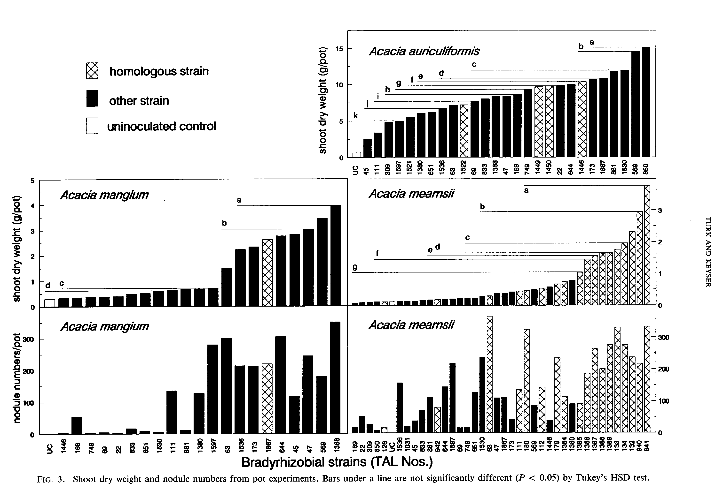
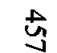
458
CAN. J. MICROBIOL. VOL. 38, 1992
In terms of shoot dry weight, Acacia auriculiformis, Macroptilium atropurpureum, Albizia lebbeck, and Paraserianthes falcataria formed a group distinct from the other species (Fig. 2). Acacia mearnsii was the only species whose shoot dry weights were not significantly correlated with shoot dry weights of Macroptilium atropurpureum by Spearman rank correlation (Table 4).

Pot experiments
Nodulation and shoot dry weight response patterns observed in pouch experiment B were also evident in the pot experiments (Fig. 3). Most strains tested were effective on Acacia auriculiformis in pots, with all but 5 of 27 producing significantly higher shoot dry weight than the uninoculated control. As in pouches, a large proportion of strains were relatively ineffective on both Acacia mangium and Acacia mearnsii. Correlation of shoot dry weight in the pot experiments with the dry weights from the same strains used in pouch experiment B yielded significant Spearman correlation coefficients (P < 0.05) for shoot dry weight and nodule numbers of Acacia mangium and Acacia mearnsii (Table 4).
The 10 strains with the highest dry weights for Acacia mearnsii in pots were all homologous strains (Fig. 3). Homologous strains also were among the best strains for Acacia auriculiformis and Acacia mangium in the pot experiments.

Discussion
Effective nodulation of Gliricidia septum, Calliandra calothyrsus, and Leucaena leucocephala, by rhizobia from each of the three species but failure to nodulate effectively with most rhizobia isolated from other legumes indicates that Gliricidia septum, Calliandra cadothyrsus, and Leucaena leucocephala belong to a common effectiveness group. Previously, Leucaena leucocephala had been reported to nodulate with a strain isolated from Calliandra calothyrsus (Halliday and Somasegaran 1983) but without information on effectiveness. Other researchers found Gliricidia septum (Somasegaran et al. 1989) and Gliricidia maculata (Akkasaeng et al. 1986) to nodulate effectively with fast-growing rhizobial strains. Our data conflict with unsubstantiated reports that Gliricidia septum (Date 1977; Dreyfus et al. 1987; Peoples et al. 1989; Trinick 1982) and Calliandra (Peoples et al. 1989) nodulate with "cowpea," "slowgrowing," or bradyrhizobial strains.
The results from pouch experiment A support evidence that Sesbania grandiflora has highly specific rhizobial requirements (Abdel Magid et al. 1988; Johnson and Allen 1952; Ndoye et al. 1990; Trinick 1982). Pouch experiment A data also substantiate reports of specificity for effectiveness of Robinia pseudoacacia (Allen and Allen 1981; NifTAL and FAO 1984). Allen and Allen (1981) concluded that Robinia pseudoacacia is specific for both effectiveness and nodulation, but data in pouch experiment A show Robinia pseudoacacia to nodulate ineffectively with a wide variety of legumes. Other researchers (Burton 1977; Crow et al. 1981; Wilson 1944) have also found ineffective nodulation of Robinia pseudoacacia with rhizobia isolated from a variety of hosts.
Based on the pattern of effective nodulation in pouch experiment A and on cluster analyses and rank correlation of shoot dry weight and nodule numbers in pouch experiment B, Acacia auriculiformis, Albizia lebbeck, Paraserianthes falcataria, and Tephrosia candida appear to be promiscuous for both nodulation and effectiveness, while Acacia mearnsii is promiscuous for nodulation but specific for effectiveness, and Acacia mangium and Lysiloma lysiliqua are specific for both nodulation and effectiveness. These data support the findings of Allen and Allen (1939) for Albizia lebbeck and of Galiana et al. (1990) for Acacia mangium, but are in disagreement with an unsubstantiated report that Albizia lebbeck is specific in its rhizobial requirements (Duhoux and Dommergues 1985).
Based on all of the experiments conducted, the trees studied can be categorized based on effective nodulation with Rhizobium or Bradyrhizobium and specificity for nodulation and effectiveness (Table 5). This classification scheme is similar to those proposed by Graham and Hubbell (1975), Date (1977), and Date and Halliday (1980).
The results suggest that species-specific inoculants should be used with trees such as Sesbania grandiflora, Robinia pseudoacacia, and Acacia mearnsii that are specific for effectiveness. A common inoculant could be developed for Leucaena leucocephala, Gliricidia septum, and Calliandra calothyrsus, an expansion of the host range suggested by Somasegaran et al. (1989). Similarly, a single inoculant could be developed for use with several tree species that are promiscuous for both nodulation and effectiveness. However, because no strains in pouch experiment B were distinctly superior for all trees in this category, it would seem
TURK AND KEYSER
prudent to develop an individual inoculant for each species. Another approach would be to develop a group inoculant consisting of a mixture of highly effective strains for each species. The data suggest that MPN assays conducted with
Leucaena leucocephala, Gliricidia sepium, or Calliandra calothyrsus should provide a reasonable estimate of the rhizobial population present capable of effectively nodulating the other two species. Similarly, Macroptilium atropurpureum will likely provide a reasonable rhizobial density estimate for tree species that nodulate with Bradyrhizobium and are promiscuous for nodulation, such as Acacia auriculiformis and Acacia mearnsii. An assessment of effectiveness measured along with an MPN assay, such as described by Brockwell et al. (1988) for Trifolium subterraneum and Medicago sativa, would be useful in determining the "effective population" of rhizobia that nodulate particular tree species.

Acknowledgements
The authors thank Patty Nakao, Kathy MacGlashan, and Joe Rourke for excellent technical assistance. This research was supported in part by USAID cooperative agreement DAN-4177-A-00-6035-00 to the NifTAL Project.
Abdel Magid, H.M., Singleton, P.W., and Tavares, J.W. 1988. Sesbania-Rhizobium specificity and nitrogen fixation. Desert Plants, 9(2): 45-47.
Akkasaeng, R., Whiteman, P.C., and Date, R.A. 1986. Rhizobium requirements for two accessions of Gliricidia maculata. Tropical Grasslands, 20(1): 26-29.
Allen, O.N., and Allen, E.K. 1936. Root nodule bacteria of some leguminous plants: I. Cross-inoculation studies with Yigna sinensis L. Soil Sci. 42(1): 61-77.
Allen, O.N., and Allen, E.K. 1939. Root nodule bacteria of some tropical leguminous plants: II. Cross-inoculation tests within the cowpea group. Soil Sci. 47(1): 63-76.
Allen, O.N., and Allen, E.K. 1981. The Leguminosae: a source book of characteristics, uses, and nodulation. University of Wisconsin Press, Madison, Wis.
Barnet, Y.M., Catt, P.C., and Hearne, D.H. 1985. Biological nitrogen fixation and root-nodule bacteria (Rhizobium sp. and Bradyrhizobium sp.) in two rehabilitating sand dune areas planted with Acacia spp. Aust. J. Bot. 33: 595-610.
Brockwell, J., Holliday, R.A., and Pilka, A. 1988. Evaluation of the symbiotic nitrogen-fixing potential of soils by direct microbiological means. Plant Soil, 108: 163-170.
Burton, J. C. 1977. Associations of some uncommon leguminous plants with various rhizobia. Coll. Trop. Agric. Misc. Publ. (LJniv. Hawaii), 145: 381-384.
Burton, J. C. 1979. Rhizobium species. In Microbial technology. 2nd ed. Vol. I. Academic Press, New York. pp. 29-58.
Crow, V.L., Jarvis, B.D.W., and Greenwood, R.M. 1981. Deoxyribonucleic acid homologies among acid-producing strains of Rhizobium. Int. J. Syst. Bacteriol. 31: 152-172.
Date, R.A. 1977. Inoculation of tropical pasture legumes. Coll. Trop. Agric. Misc. Publ. (Univ. Hawaii), 145: 293-3311.
Date, R.A. 1982. Assessment of the rhizobial status of the soil. In Nitrogen fixation in legumes. Edited by J.M. Vincent. Academic Press, Sydney, Australia. pp. 85-94.
Date, R.A. 1991. Nitrogen fixation in Desmanthus: strain specificity of Rhizobium and responses to inoculation in acidic and alkaline soil. Tropical Grasslands, 25: 47-55.
Date, R.A., and Halliday, J. 1980. Relationships between Rhizobium and tropical forage legumes. In Advances in legume
459
science. Edited by R.J. Summerfield and A. H. Bunting. Royal Botanic Gardens, Kew. pp. 597-601.
Davis, P.E. 1982. Desmanthus virgatus as a test plant for dilutionfrequency infection tests using Leucaena leucocephala rhizobia. Soil Biol. Biochem. 14: 313-314.
Dommergues, Y.R. 1987. The role of biological nitrogen fixation in agroforestry. In Agroforestry, a decade of development. Edited by H.A. Steppler and P.K.R. Nair. International Council for Research in Agroforestry (ICRAF), Nairobi, Kenya. pp. 245-271.
Dreyfus, B.L., and Dommergues, Y.R. 1981. Nodulation of Acacia species by fast- and slow-growing tropical strains of Rhizobium. Appl. Environ. Microbiol. 41(1): 97-99.
Dreyfus, B.L., Diem, H.G., Freire, J., et al. 1987. Nitrogen fixation in tropical agriculture and forestry. In Microbial technology in the developing world. Edited by E.J. DaSilva, Y.R. Dommergues, E.J. Nyns, and C. Ratledge. Oxford University Press, Oxford. pp. 9-50.
Duhoux, E., and Dommergues, Y.R. 1985. The use of nitrogen fixing trees in forest and soil restoration in the tropics. In Biological nitrogen fixation in Africa: proceedings of the first conference of the African association for biological nitrogen fixation. Edited by H. Ssali and S.O. Keya. Matianum Press Consultants, Nairobi. pp. 384-400.
Fred, E.B., Baldwin, LL., and McCoy, E. 1932. Root nodule bacteria and leguminous plants. Univ. Wisconsin Stud. Sci. 5.
Galiana, A., Chaumont, J., Diem, H.G., and Dommergues, Y.R. 1990. Nitrogen-fixing potential of Acacia mangium and Acacia auriculiformis seedlings inoculated with Bradyrhizobium and Rhizobium spp. Biol. Fertil. Soils, 9: 261-267.
Gibson, A.H., Dreyfus, B.L., and Dommergues, Y.R. 1982. Nitrogen fixation by legumes in the tropics. In Microbiology of tropical soils and plant productivity. Edited by Y.R. Dommergues and H.G. Diem. Martinus Nijhoff/Dr. W. Junk Publishers, The Hague. pp. 37-73.
Graham, P.H., and Hubbell, D. H. 1975. Legume Rhizobium relationships in tropical agriculture. In Tropical forages in livestock production systems. Edited by E.C. Doll and G.O. Mott. ASA Spec. Publ. 24: 9-21.
Halliday, J., and Somasegaran, P. 1983. Nodulation, nitrogen fixation, and Rhizobium strain affinities in the genus Leucaena. In Leucaena research in the Asian Pacific Region. Proceedings of a workshop held in Singapore, 23-26 November, 1982, International Development Research Centre, Ottawa, Ont. pp. 27-32.
Hughes, C.E., and Styles, B.T. 1987. The benefits and potential risks of woody legume introductions. Int. Tree Crops J. 4: 209-248.
Jenkins, M.B., Virginia, R.A., and Jarrell, W.M. 1987. Rhizobial ecology of the woody legume mesquite (Prosopis glandulosa) in the Sonoran desert. Appl. Environ. Microbiol. 53(1): 36-40.
Johnson, M.D., and Allen, O.N. 1952. Nodulation studies with special reference to strains isolated from Sesbania species. Antonie van Leeuwenhoek J. Microbiol. Serol. 18(1): 1-12.
Ndoye, L, Tomekpe, K., Dreyfus, B., and Dommergues, Y.R. 1990. Sesbania and Rhizobium symbiosis: nodulation and nitrogen fixation. In Perennial Sesbania species in agroforestry systems. Edited by B. Macklin and D.O. Evans. Nitrogen Fixing Tree Association, Waimanalo, Hawaii.
NifTAL and FAO. 1984. Legume inoculants and their use. Food and Agriculture Organization of the United Nations, Rome.
Peoples, M.B., Faizah, A.W., Rerkasem, B., and Herridge, D.F. 1989. Methods for evaluating nitrogen fixation by nodulated legumes in the field. Australian Centre for International Agricultural Research, Canberra.
Sambrook, J., Fritsch, E.F., and Maniatis, T. 1989. Molecular cloning: a laboratory manual. 2nd ed. Vol. 1. Cold Spring Harbor Laboratory Press, Cold Spring Harbor, N.Y.
SAS Institute. 1986. SAS users' guide: statistics. SAS Institute Inc., Cary, N.C.
460
Singleton, P.W. 1983. A split-root growth system for evaluating the effect of salinity on components of the soybeanlRhizobium japonicum symbiosis. Crop Sci. 23: 259-262.
Somasegaran, P., and Hoben, H.J. 1985. Methods in legumeRhizobium technology. NifTAL Project, University of Hawaii, Paia.
Somasegaran, P., Keyser, H.H., and Roskoski, J.P. 1989. Rhizobial requirement and inoculation response of Gliricidia sepium (Jacq.) Walp. The 12th North American Symbiotic Nitrogen Fixation Conference Proceedings. Ames, Iowa. p. 77.
Trinick, M.J. 1965. Medicago sativa nodulation with Leucaena leucocephala root-nodule bacteria. Aust. J. Sci. 27: 263-264.
Trinick, M.J. 1968. Nodulation of tropical legumes. I. Specificity in the Rhizobium symbiosis of Leucaena leucocephala. Exp. Agric. 4: 243-253.
CAN. J. MICROBIOL. VOL. 38, 1992
Trinick, M.J. 1980. Relationships amongst the fast-growing rhizobia of Lablab purpureus, Leucaena leucocephala, Mimosa spp., Acacia ,f'arnesiana, and Sesbania grandiflora and their affinities with other rhizobial groups. J. Appl. Bacteriol. 49: 39-53.
Trinick, M.J. 1982. Host-Rhizobium associations. In Nitrogen fixation in legumes. Edited by J.M. Vincent. Academic Press, Sydney. pp. 111-122.
Vincent, J.M. 1970. A manual for the practical study of rootnodule bacteria. IBP Handbook No. 15. Burgess and Son (Abingdon) Ltd., Berkshire.
Wilkinson, L. 1990. SYSTAT: the system for statistics. SYSTAT, Inc., Evanston, Ill.
Wilson, J.K. 1944. Over five hundred reasons for abandoning the cross-inoculation groups of the legumes. Soil Sci. 58: 61-69.

